LOAD CSV WITH HEADERS FROM "file:///airbnb_ny_all_cleaned.csv"AS line

CREATE (:Airbnb { airbnb: line.Airbnb_id, Price: line.price,address: line.Address1});

MATCH (n:Airbnb) RETURN n

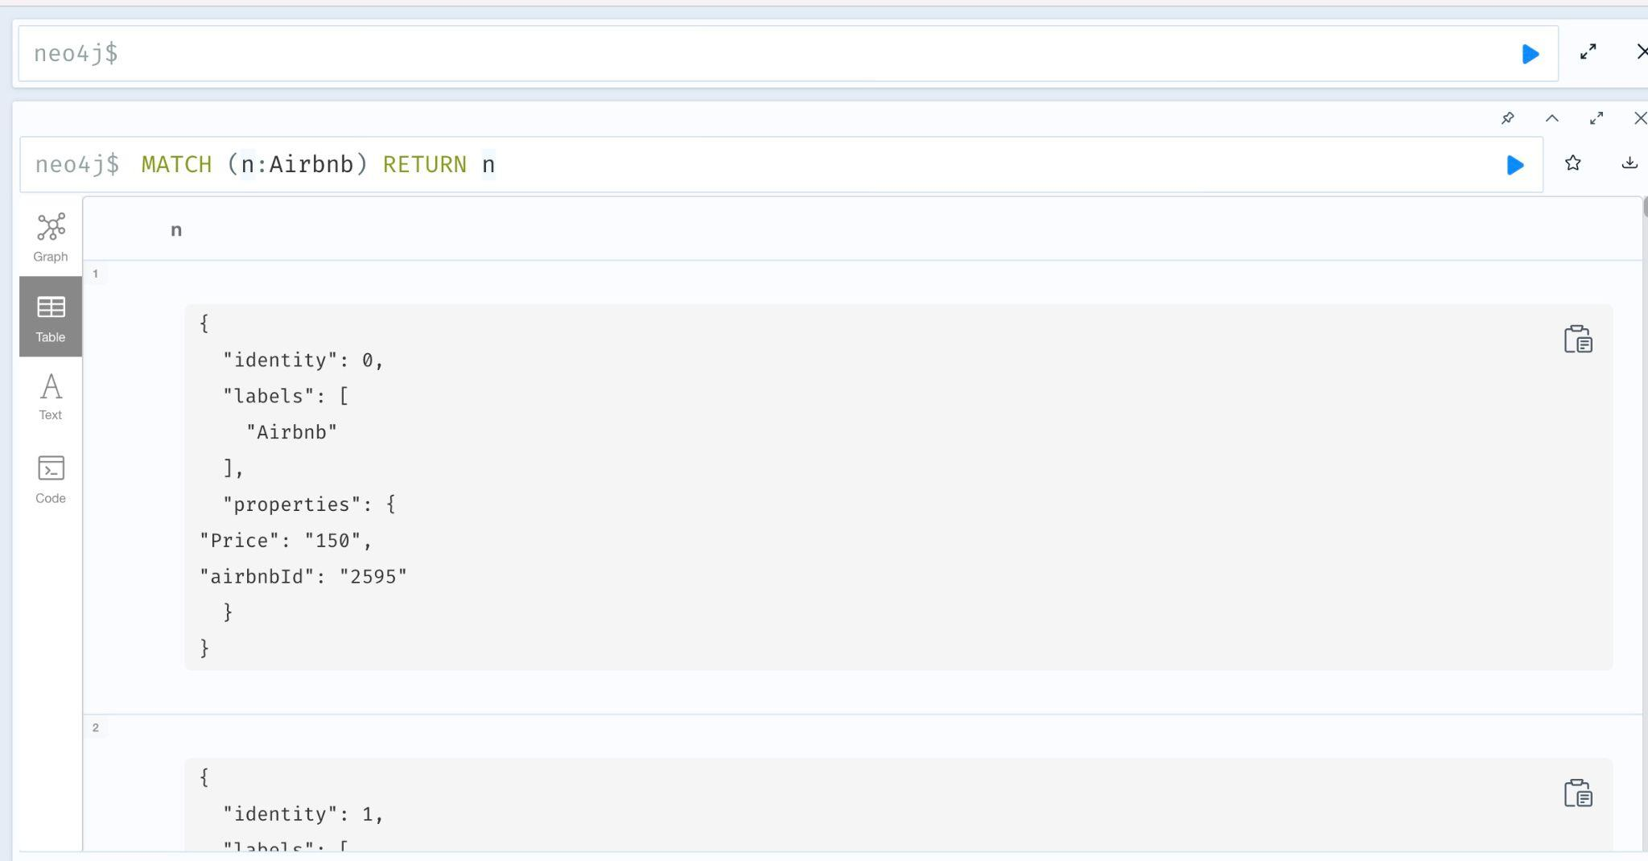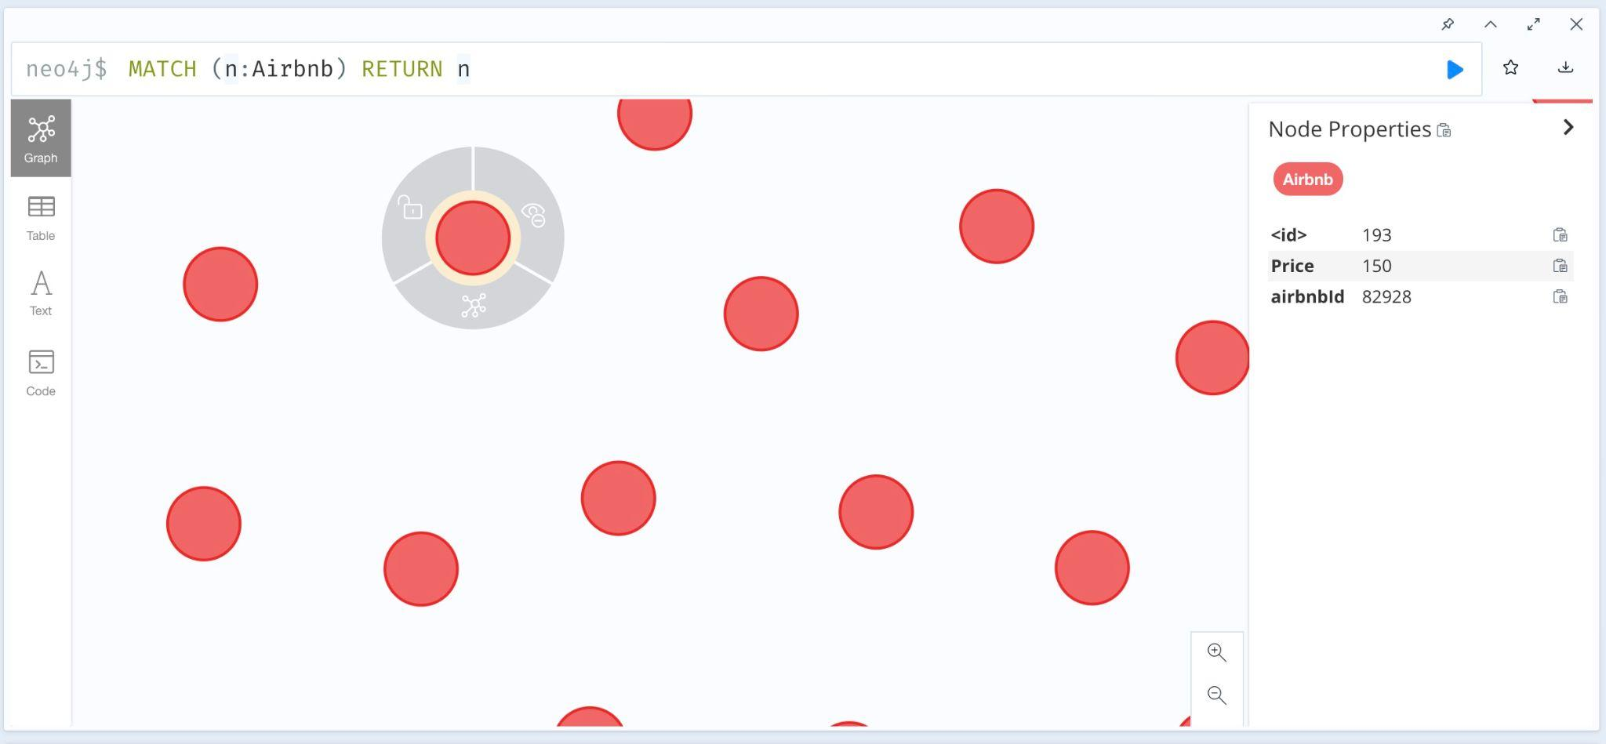

LOAD CSV WITH HEADERS FROM "file:///restaurant_ny_cleaned.csv" AS row

CREATE (:restaurant{ name: row.Restaurant_Name, Grade: row.GRADE,address: row.Address1, claimnumber: row.Claim_Number, Borough: row.Borough_Code, zipcode: row.ZIPCODE,date: row.INSPECTION_DATE});

MATCH (n:restaurant) RETURN n

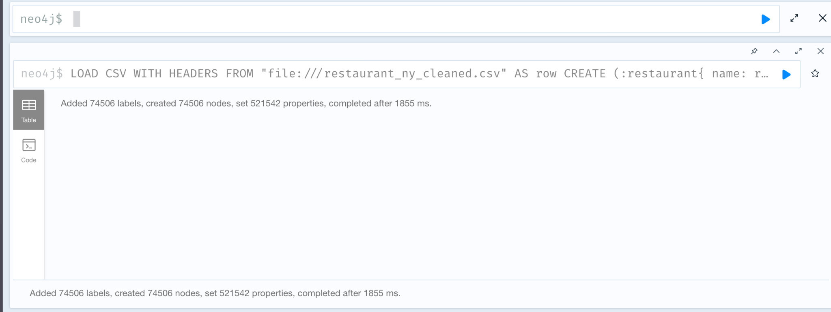

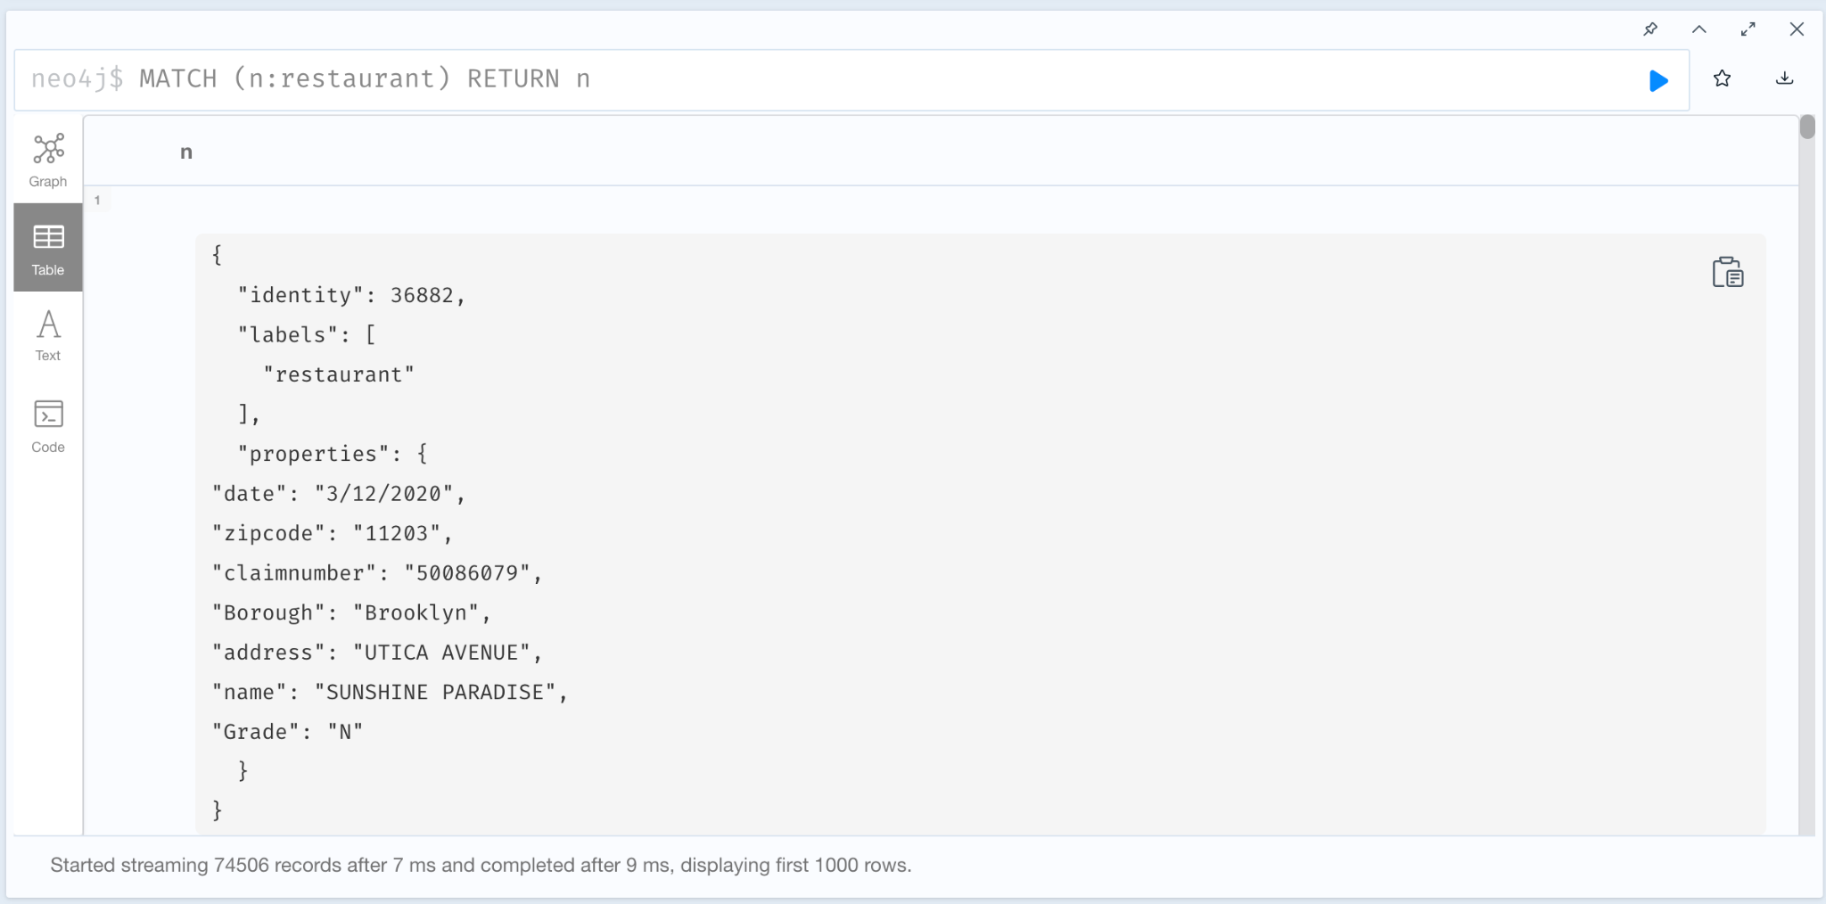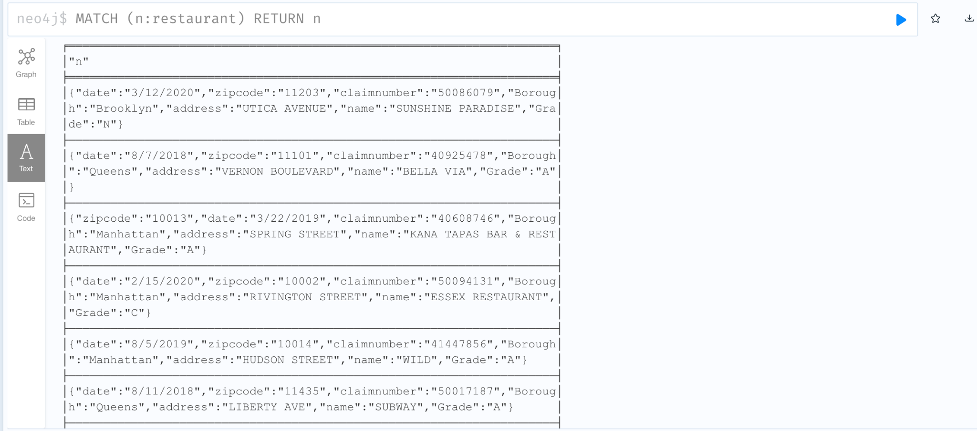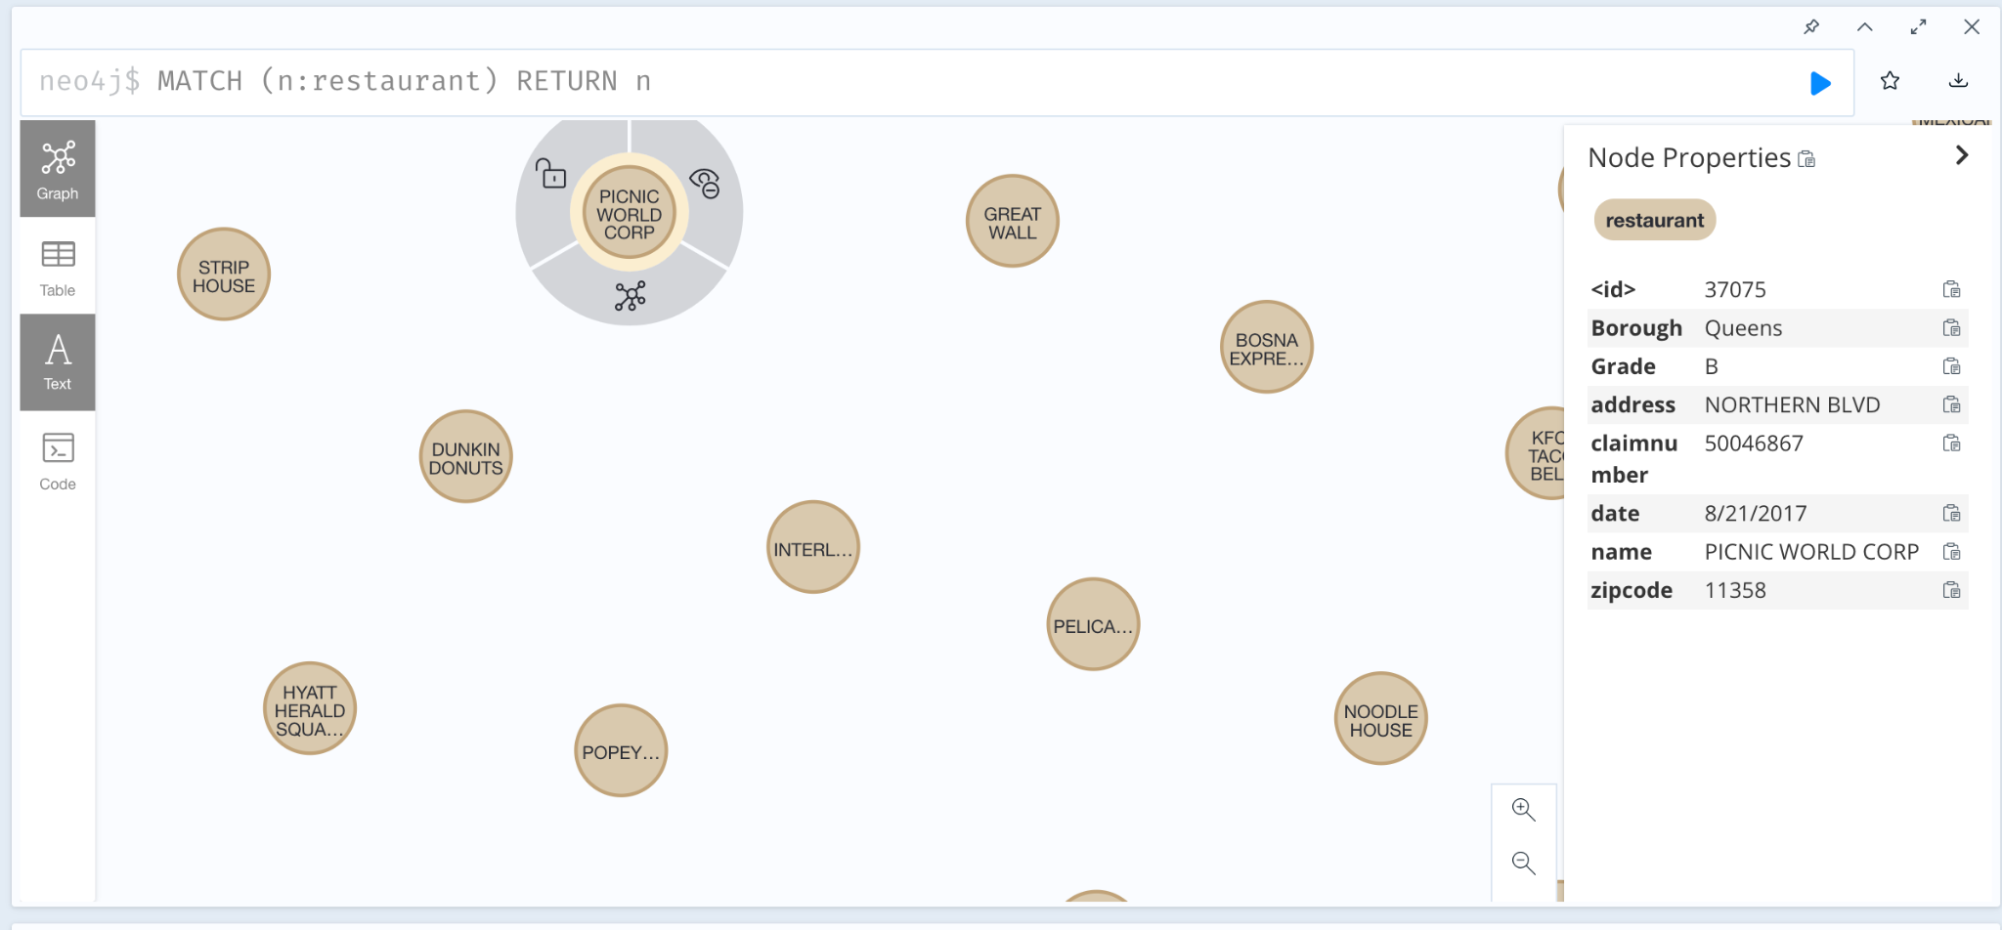

LOAD CSV WITH HEADERS FROM "file:///hotel_ny(1).csv" AS row1

CREATE (:hotel{ id: row1.hotel_id, address: row1.address1,cityr: row1.city, postal: row1.postal_code, star: row1.star_rating,high: row1.high_rate, low: row1.low_rate});

MATCH (n:hotel) RETURN n